1. You are going to write a simple program to perform basic math calculations on two numbers. You will have the following lines of code in your program:  
     
     
   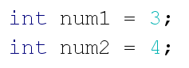
2. Declare 4 more variables: add, subtract, multiply and divide
3. Use math calculations with num1 and num2 to set the values of these 4 variables
4. Use println statements and **concatenating** to print out text similar to this:

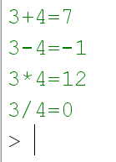

d) Add this line to your code. The “%” operation is called **modulus**. Change the values of num1 and num2 (hint: you may want to make num1 larger than num2). Print out the modulus. Continue to change values and test this until you figure out what modulus does (don’t cheat and google it!!)  
  


e) Go back to your original code. What change can you make to have the division statement print out more accurately? Experiment with different data types for your num1, num2 and also for your other variables